EFFICIENT AND EFFECTIVE ….

STANDARD AUTOMATED VALUATION MODEL
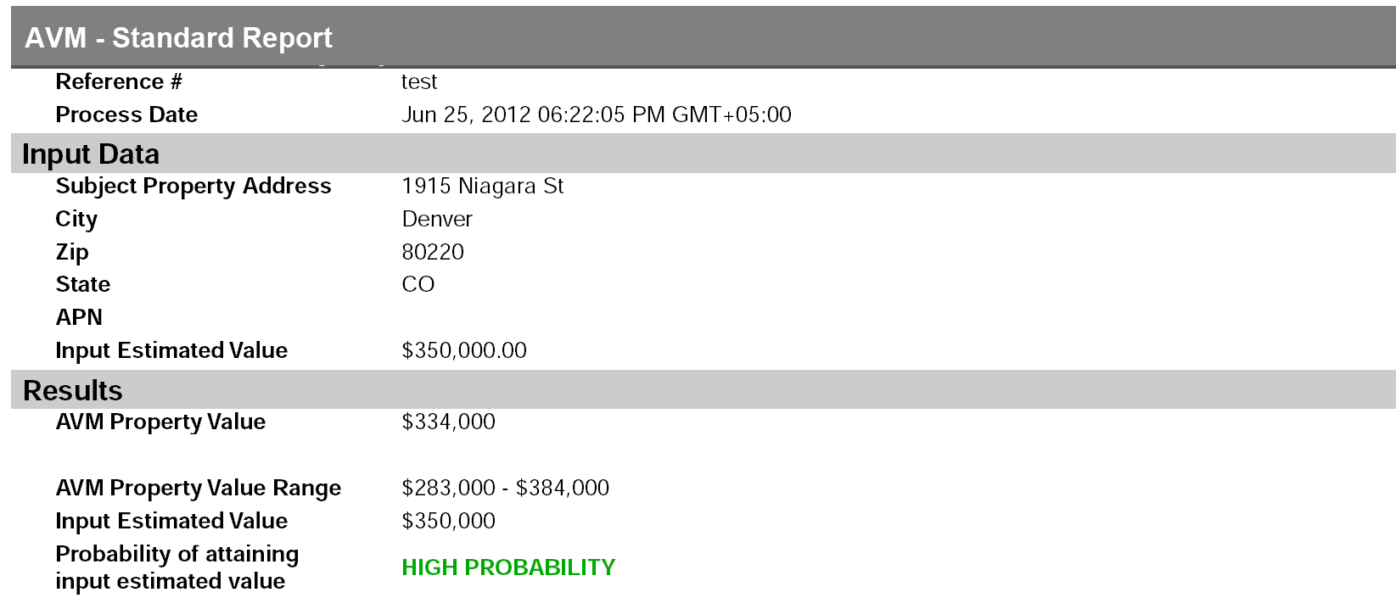
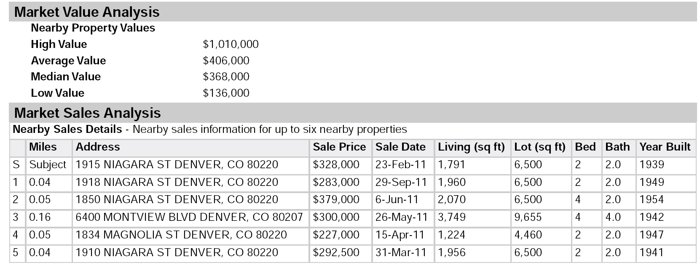
For further information please contact your ACRAnet Account Executive

